Day 2 Assignment:
- List 5 difference between Browser JS(console) vs Nodejs ?
Nodejs:

- Node doesn’t have a predefined “window” object because it doesn’t have a window to draw anything.
- “location” object is related to a particular url; that means it is for page specific. So, node doesn’t require that.
- Of course Node doesn’t have “document” object also, because it never have to render anything in a page.
- Node has “global”, which is a predefined global object. It contains several functions that are not available in browsers, because they are needed for server side works only.
- “require” object is predefined in Node which is used to include modules in the app.
In Node everything is a module. You must keep your code inside a module.
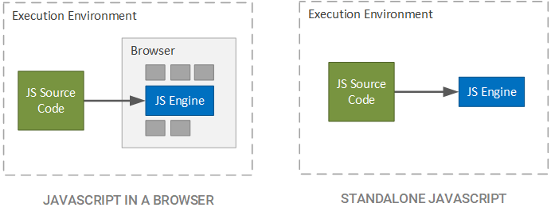

Browser js(Console) :
- “window” is a predefined global object which has functions and attributes, that have to deal with window that has been drawn.
- “location” is another predefined object in browsers, that has all the information about the url we have loaded.
- “document”, which is also another predefined global variable in browsers, has the html which is rendered.
- Browsers may have an object named “global”, but it will be the exact one as “window”.
- Browsers don’t have “require” predefined. You may include it in your app for asynchronous file loading.
- Moduling is not mandatory in client side JavaScript, i.e. in browsers.
As both of them are JavaScript executor, and Node uses the JavaScript engine of a browser (Chrome), so differences are not much there. It is just the Node wrapper which has been written on top of JavaScript V8 Runtime engine, which is deleting few objects and also including some according to the requirement of Node.

